# CS 255 System Design Document Template

This template lays out all the different sections that you need to complete for Project Two. Each section has guidance to prompt your thinking. You will need to continually reference the interview transcript as you work to make sure that you are addressing your client’s needs. There is no required length for the final document. Instead the goal is to complete each section based on what your client’s needs are. Remove this note when you are finished, and replace all bracketed text with the relevant information.

## UML Diagrams

### UML Use Case Diagram

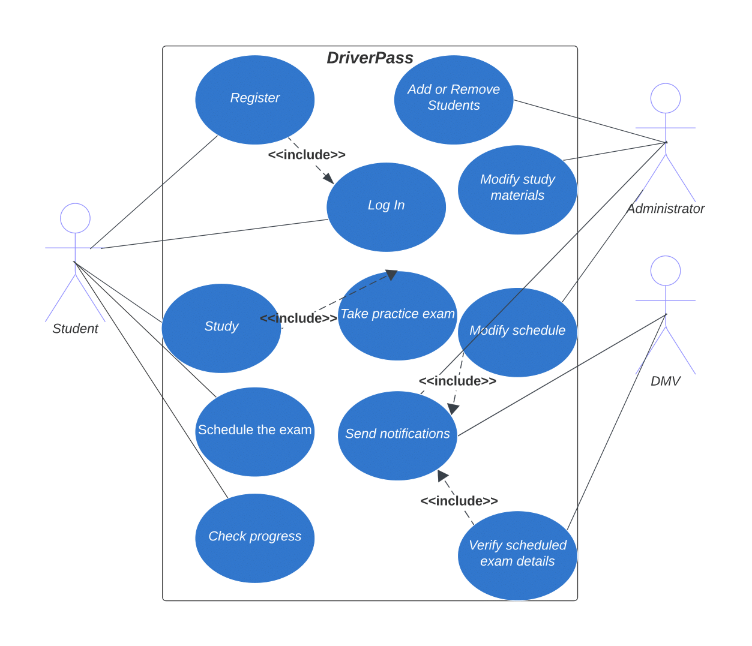

### UML Activity Diagrams

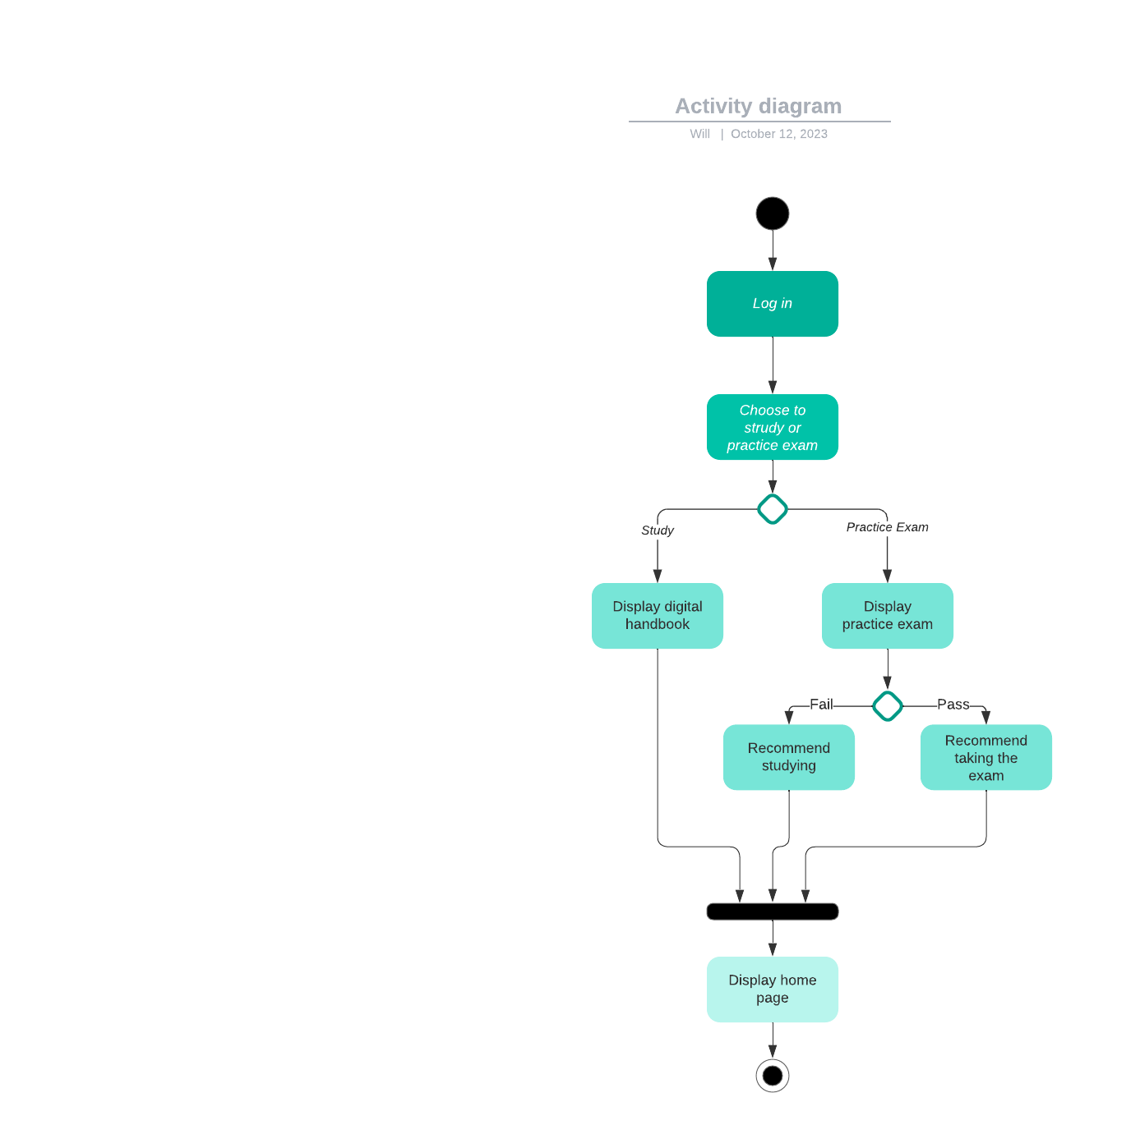

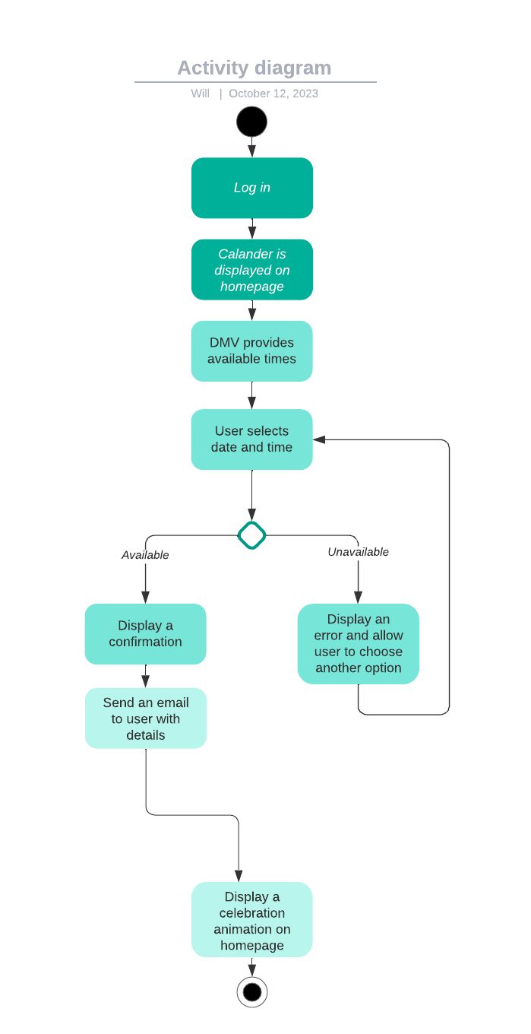

### UML Sequence Diagram

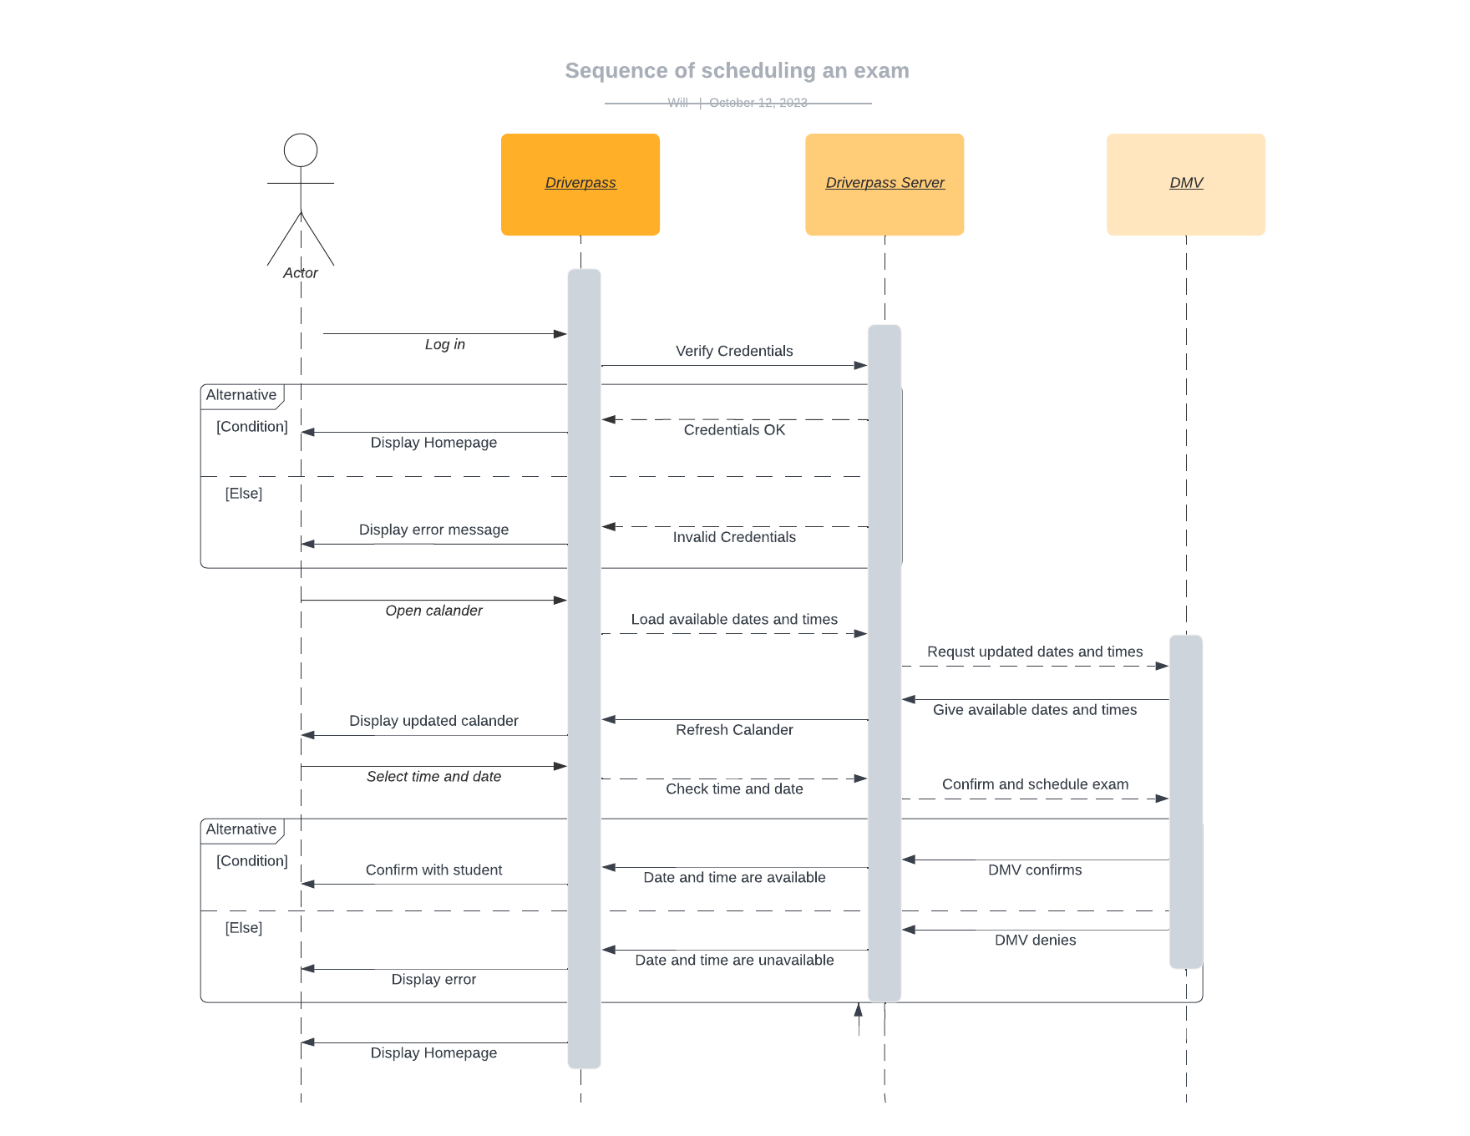

### UML Class Diagram

## Technical Requirements

*In terms of hardware, the Driverpass system should rely on a scalable and reliable server infrastructure. This should include servers capable of handling web hosting, database management, and cloud storage to ensure seamless performance and data integrity. The hardware should also support load balancing and redundancy for high availability and fault tolerance.*

*On the client-side, the system should be accessible from various devices, including desktop computers, laptops, tablets, and mobile phones. As such, it requires responsive web design to accommodate different screen sizes and resolutions. To ensure optimal user experience and efficient data processing, the hardware should support fast processors, ample memory, and a secure network environment. Regular maintenance and upgrades of the hardware infrastructure should also be a part of the technical requirements to accommodate future growth.*

*For the software aspect, the system will need secure, efficient, and scalable software. This includes a web server, application server, and a relational database management system (RDBMS). Security software such as firewalls and intrusion detection systems should be in place to protect against potential threats and data breaches. The software tools should enable the development of the user interface, back-end functionality, and seamless integration with external systems such as the DMV for updates and notifications. Furthermore, regular software updates and patches should be part of the system's maintenance to address security vulnerabilities and ensure compliance with evolving industry standards and regulations.*